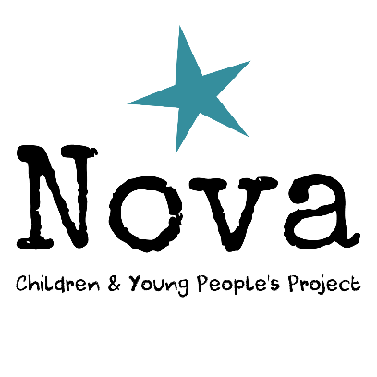
Project Worker: PW2 Request Form
Name:
Date:

Criteria for PW2
- Ability to work effectively with a diverse range of children who attend the service; independently and confidently following given strategies and behaviour plans for each individual.
- Ability to effectively manage moderate to high level challenging behaviour with occasional assistance from a senior member of staff.
- Ability to complete Team Teach techniques* with minimal guidance from a senior member of staff.
- Ability to independently and confidently complete all personal care tasks.
- Ability to follow a seizure management plan and administer emergency medication* under the supervision of a senior member of staff.
- Ability to administer feeds (both bolus and pump) via a PEG* under the supervision of a senior member of staff.
- Ability to administer medication via a PEG* under the supervision of a senior member of staff.

* Following completion of relevant training

Please explain how you feel meet the above criteria, including examples of when you have demonstrated these skills during your time as a Project Worker with Nova Children’s Project.

Project Worker: PW3 Request Form
Name:
Date:

Criteria for PW3
- Ability to work effectively with all the children who attend the service; independently developing and utilising appropriate strategies for each individual.
- Ability to be the lead when working with a child who requires 2:1 staffing and guide another member of staff.
- Ability to independently and confidently manage frequent high level challenging behaviour.
- Ability to lead Team Teach techniques* and guide another member of staff.
- Ability to independently and confidently follow a seizure management plan and administer emergency medication*.
- Ability to independently and confidently administer feeds (both bolus and pump) via a PEG*.
- Ability to independently and confidently administer medication via a PEG*.
- Ability to take the lead and guide another staff member during moving & handling tasks, including the use of a hoist*.
- Ability to discuss sensitive topics with parents/carers as necessary.
- Ability to advise and model strategies to other staff and guide them through relevant tasks where necessary.
- Ability to independently and confidently coordinate a session.

* Following completion of relevant training

Please explain how you feel meet the above criteria, including examples of when you have demonstrated these skills during your time as a Project Worker with Nova Children’s Project.

